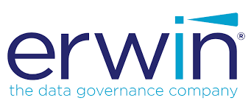

Cognos Reverse Smart Connector

User Guide

Version 1.1

# 

Table of Contents

1. Introduction 3

1.1 Overview 3

1.2 Scope 3

1.3 Supported Versions 3

1.4 Supported Operating Systems 3

2. Connector Features 3

2.1 Automatic Code Export 3

2.2 Mapping Creation 3

2.2.1 Business Rules 3

2.2.2 Extended Properties 4

2.2.3 Source Extract SQL 4

2.3 Versioning 4

2.4 Metadata Sync up 4

2.5 Scheduling 4

2.6 Enhancements 4

3. Using the Connector 4

3.1 Pre-Requisites 4

3.2 Connector Options 5

3.3 Configuring the Connector 7

3.4 Running the Connector 7

3.5 Scheduling the Connector 10

4. Troubleshooting 13

4.1 Logging 13

1. Introduction
   1. Overview

The Cognos Reverse Smart Connector is used to reverse engineer Cognos reports and create mappings in Erwin Data Intelligence Suite (DIS). The Connector creates the mappings under individual Subject areas based on the folder structure defined in the exported package. This ensures that the generated folder structure in DIS is similar to the folder structure available in Cognos Analytics.

The connector uses the Cognos model and exported package files as input and analyses them to generate

mappings in Erwin Data Intelligence Suites Mapping Manager. Every report available in the package file will have a corresponding mapping in the Mapping manager.

* 1. Scope
* The Connector requires the Cognos Model and Package files in .xml format.
* The exported package should contain report information for the connector to create mappings successfully.
* The Connector only pulls Report Object information from the input files.
* For proper versioning of mappings to take place, the package export file generated using Cognos should be consistent and point to the same folder as previous exports.
  1. Supported Versions

Cognos versions 11.0

* 1. Supported Operating Systems

Windows/Linux

# 

1. Connector Features
   1. Automatic Code Export

* Automated Package Export using “Cognos Auto Export” Smart Connector based on Cognos Folder & Repository

Note: This is a separate connector.

* 1. Mapping Creation
* The Connector can handle multiple package files in a single run and to create mappings in Erwin DIS.
* Mappings are created in DIS based on the Cognos Package and the Report Name. Every report will have a dedicated mapping under a subject area named after the Package it uses
* The Connector can also parse Oracle/MS-SQL queries used in the reports to generate the required mappings.
  + 1. Business Rules
* Any expressions used in the Cognos Report either at the report level or the Model Level are captured in the Mapping under the Business Rule Column
  + 1. Extended Properties
* The Mapping extended properties contain information on the deployed Cognos package used as a source to the Cognos report.
  + 1. Source Extract SQL
* NA
  1. Versioning
* The connector supports versioning of mappings. For every subsequent run of the connector, older mappings will be archived, and the latest version of the mapping will be available based on the input files provided.
  1. Metadata Sync up
* The Connector also supports a Metadata Sync up feature, where the mappings generated will be synced with the metadata information available in Erwin Metadata Manager based on the System and Environment values.
* For the metadata sync up to work, the Metadata should be exported from Erwin Metadata Manager using the connector option “Create/Refresh Metadata File”.
  1. Scheduling
* The Connector also provides a scheduling option which may be used along with the automatic code export to periodically refresh the mappings in DIS with the latest versions of the Cognos Reports.
* Scheduling can also provide e-mail notification of the Job run based on the SMTP settings configured.
* The detailed steps to schedule the connector are provided in section 3.5
  1. Enhancements
* Currently only Oracle and MS-SQL query parsing is supported. Queries using Cognos specific functions/syntax are not fully supported.

1. Using the Connector
   1. Pre-Requisites

* The package file provided as input should be exported using the ‘Export’ option in Cognos Administration Console. The package.xml file should be extracted from the generated .zip file and should be provided as input to the connector.
* The model.xml file provided as input should contain information on the objects used to build the report.
* The model.xml file should be copied from the Cognos project Directory and not be exported from the Cognos Framework Manager
* The input files must be placed in a directory on the DIS server in a location which the user has access to.
* The model file and package xml files should be stored in separate directories. The Package directory may contain one or more package files.
* The input package files must contain report information for the connector to run successfully.
* SMTP configuration needs to be done to receive email alerts for Scheduled jobs.
* Metadata should be available in Erwin Mapping Manager for Metadata Sync up to work.
* Metadata should be exported using the “Create/Refresh Metadata File” option provided in the connector.
* The user running the connector should have read/write access to the directories containing the input files and the directory which the input files need to be archived depending on the options set in the connector.
  1. Connector Options

The connector provides the following options which can also be edited and saved prior to a connector run ot can also be updated at run time. The Cognos Reverse connector provides the following options:

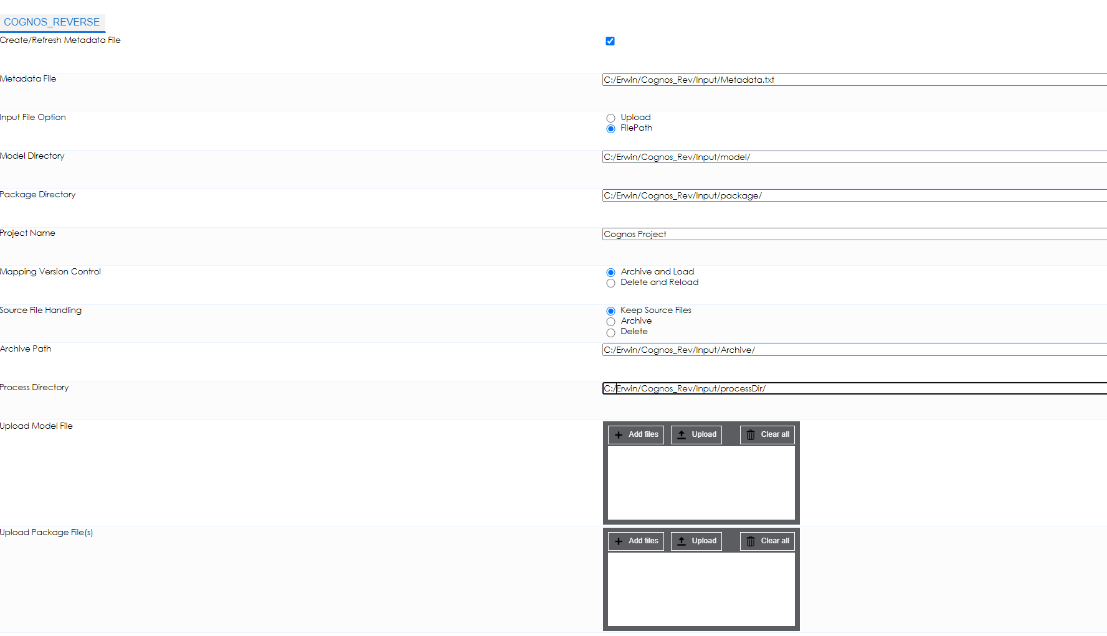

Fig: Cognos Reverse Connector Options

|  |  |
| --- | --- |
| * Create/Refresh Metadata File | Checkbox to determine if Metadata in DIS needs to be scanned and placed in a file on disk to be used by the Cognos connector. |
| * Metadata File | This file will contain Metadata information from Erwin Metadata Manager.  The previous option is used to generate the metadata file, this field determines where the file will be generated  In case Metadata sync up is not required, a blank file may be used. |
| * Input File Option | Provides the user an option to either upload the input files using the appropriate fields, or use the directory parameters to pick the input files from |
| * Model Directory | This field should contain the directory path to the Cognos model.xml file. |
| * Package Directory | This field should contain the directory path to the Cognos package.xml  file(s). |
| * Project Name | This field contains the name of the Project to be used in DIS.  If a project does not already exist, the Connector will create a new project.  If an existing project name is used, the connector will create the  mappings in the existing project. |
| * Mapping Version Control | Provides 2 options to generate mappings:   1. **Archive and Load:** Archives the current version of the mapping and creates a new version of the mapping with the updated data from the input files. 2. **Delete and Reload:** Deletes “ALL PREVIOUS VERSIONS” of the mappings based on the input files and creates a fresh mapping with version 1.0 |
| * Source File Handling | Applicable only with Input File Option set to “FilePath”. This option allows the user to determine the post processing action on the input files.  The user can select one of three options:   1. **Keep Source Files:** Does not modify the source files in any way. 2. **Archive:** Archives all files within the source model and package directories to a file path specified by the user. The naming format for the generated Archive file is “Archive_YYYYMMDD_hhmmss.zip”. 3. **Delete:** Deletes the Input Files from the directories specified |
| * Archive Path | This option is only applicable if the “Source File Handling” option is set to “Archive”. In which case, the source and target directories are archived in the specified path. |
| * Process Directory | This directory will be used by the connector to create the required temporary files during connector execution. All generated files will be deleted upon successful execution of the connector subject to proper folder permissions |
| * Upload Model File | Applicable only if the “Input File Option” is set to “Upload”. Only Cognos model.xml file should be uploaded in this field. |
| * Upload Package File(s) | Applicable only if the “Input File Option” is set to “Upload”. Only Cognos package.xml file(s) should be uploaded in this field. |

* 1. Configuring the Connector
* The field details for the connector can be updated by right clicking on the connector and clicking on “Options”, or by clicking on the gear icon under the Options column alongside the connector name.

* The values specified in these fields determine the directory paths which the connector will use to pick the input files when the Input File Options is set to “FilePath”.
* The Metadata File field should contain the path to the file which contains Metadata information.
* The Model Directory and Package Directory fields should contain the directory paths where the model and package files are stored.
* The Project Name field can contain the name of the Project to be used to create the mappings in. In case an existing project is not available, the connector will create a new project.
* The Archive Path field should contain a directory path to which the input files should be moved to in case the Archive Input Files option is selected. In case the directory is not present on the system, a new directory will be created based on the path provided and the permissions available to the user running the connector.
* All the above fields can also be edited at runtime. The changes made at runtime will not be permanent and will apply only to the current execution.
* Remember to click on the save button after making any updates to the Connector options.
  1. Running the Connector

The connector can be executed by following the steps below:

* Right click on the Project node in DIS Mapping Manager and click on “Run Template”.

­ 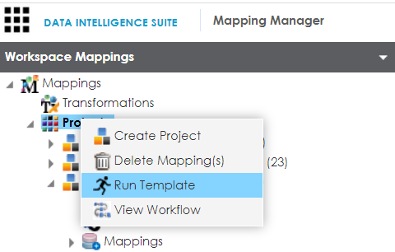

* On the next pop up window Navigate to the Tab “BI Reverse” and locate the connector “COGNOS” in the Connector List and click on “Export”.

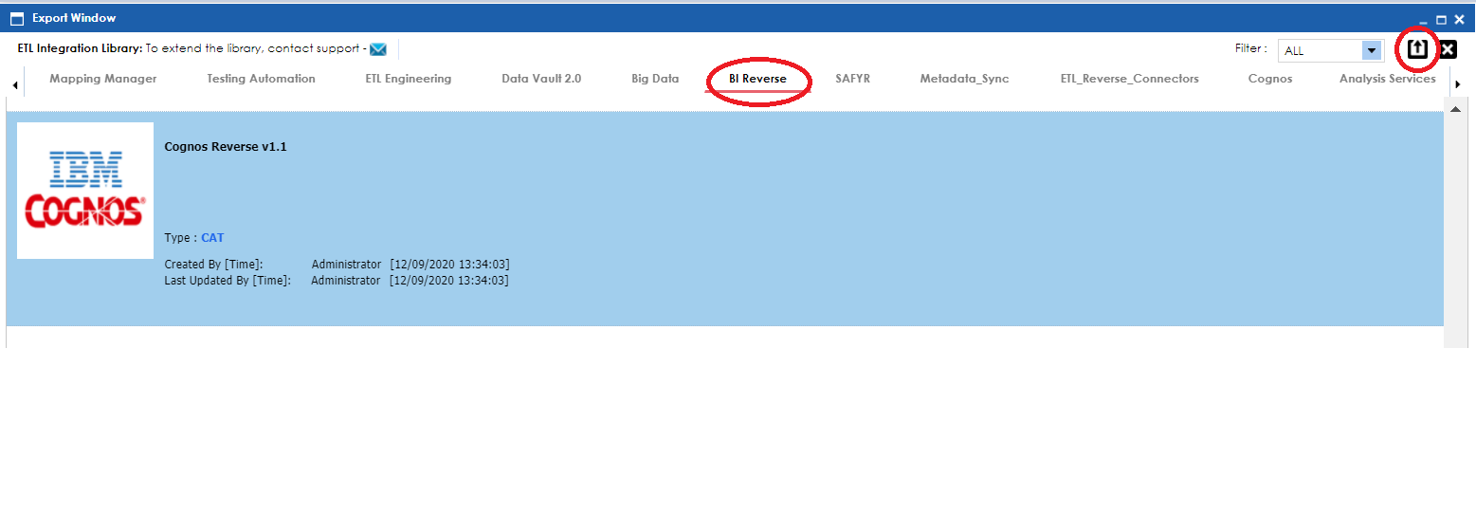

* On the next pop up window, enter the required details in the text fields as per the field descriptions in the section “3.2 Connector Options”.
* Click on the green check box in the top right corner to run the connector.

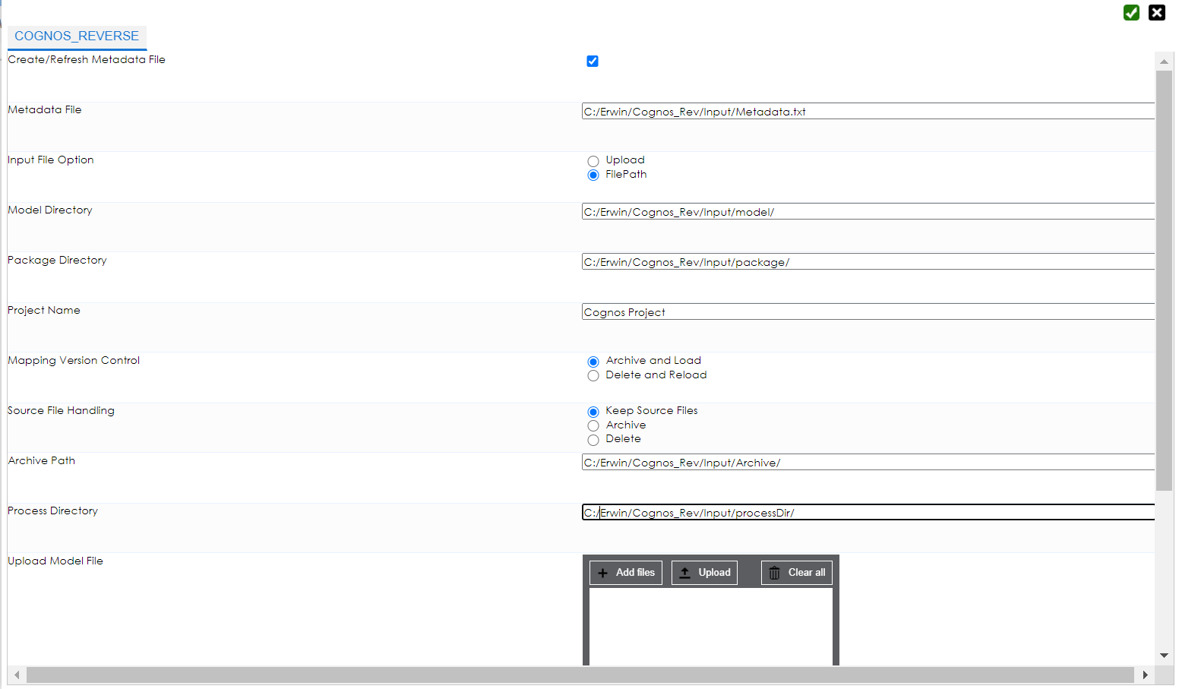 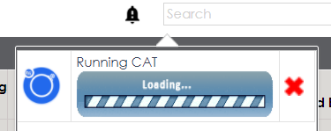

* Once the connector finishes execution, it provides a “Download File” option in the notifications pane.

This file will contain an information log on the mappings created/updated in DIS Mapping Manager.

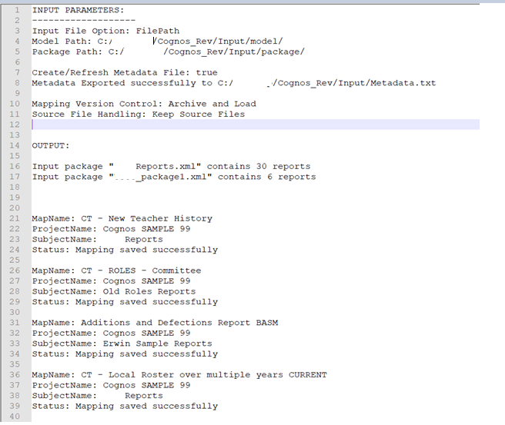

Fig: Sample Cognos Connector Log File

* Refresh the browser window and under the Mapping Manager module, check for the project created on the left-hand side of the page under the Projects Node and verify if the mappings are created.

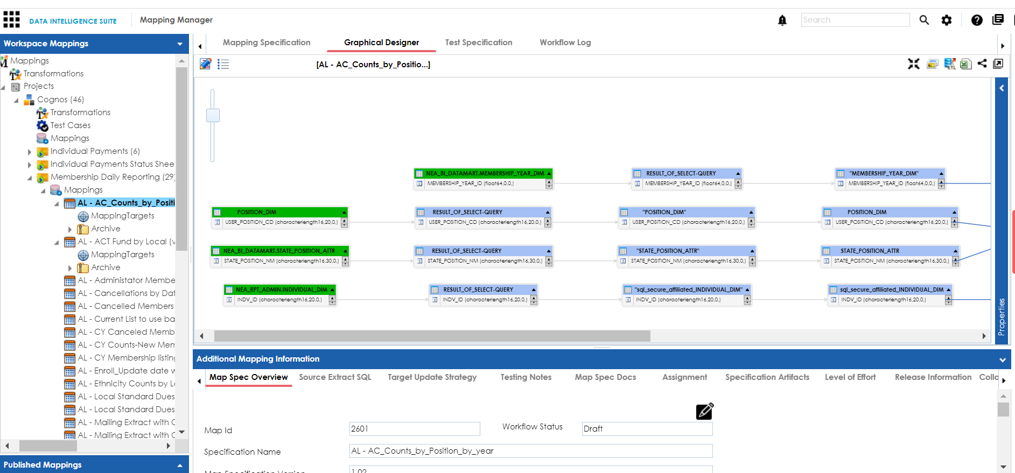

* 1. Scheduling the Connector
* The connector can also be scheduled to run at a specific point of time as a single run or configured to run at regular intervals of time.
* To schedule a connector run, navigate to the “Automation Framework” module and click on the options icon of the Cognos Connector.
* When the “CAT Menu” window opens up, click on the “Options” button (the gear icon) and make sure the input parameters provided are correct

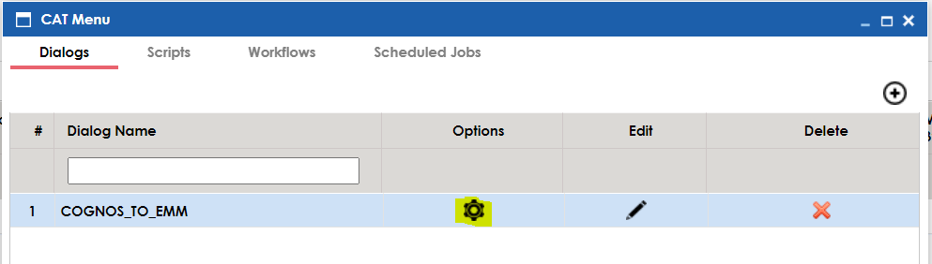

* Once the input parameters have been confirmed and saved, click on the “Scheduled Jobs” tab in the “CAT Menu Window” and click on the “+” icon on the right to create a new Scheduled Job

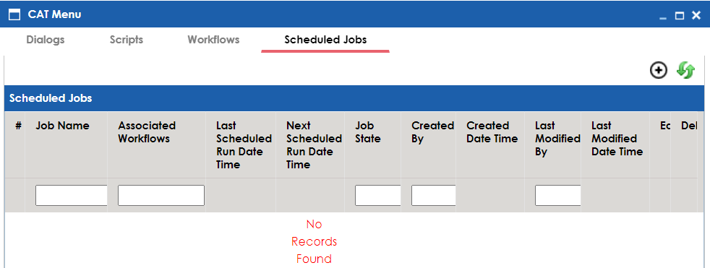

* In the Job Scheduler window, select the workflow “COGNOS” from the dropdown.

* Enter the time and Date for the connector to run in the “Schedule Job on” field.
* Select the Interval option to schedule the connector for a one time run or a recurring run. The dropdown provides 4 options:
  1. Once
  2. Every Day
  3. Every Week
  4. Every Month
* The CC List field can be used to enter e-mail id’s of any additional users separated by a comma, to send e-mail notifications of the Job runs

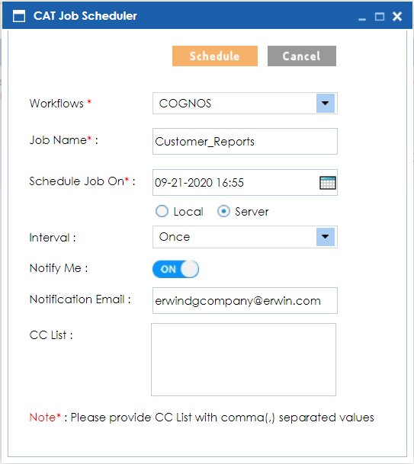

* Click on the “Schedule” button to schedule the connector run.
* The Scheduled Jobs Tab will now show the list of jobs scheduled to run.

* After the successful run of a Scheduled Job, the user will receive an email notification on the status of the job run.

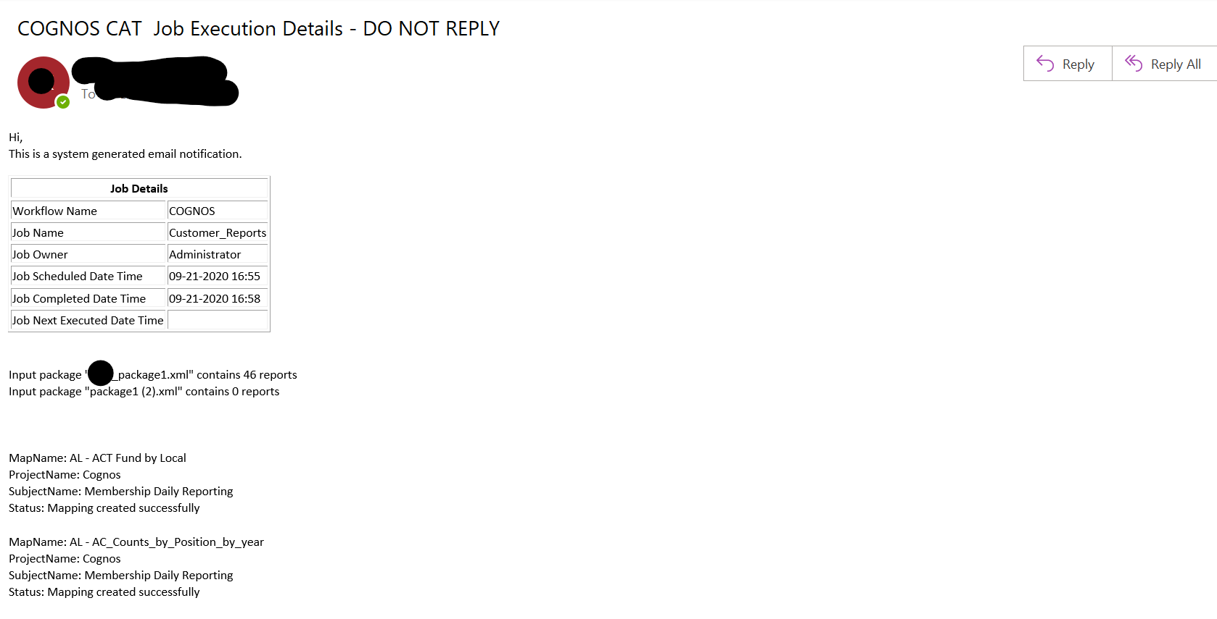

1. Troubleshooting
   1. Logging

* In case of any errors the connector creates a log file in the following location:

“Erwin SupportFilePath/Cognos_Logs/”

* The log file is a .txt file with name in the format “Cognos_Log_yyyymmdd.txt” (Eg: Cognos_Log_20200921.txt)
* This file will contain error information and the cause of failure of the connector.
* In case this file fails to provide any error information, the tomcat logs can also be checked, Navigate to the logs directory under the Tomcat Installation path and look for the latest “tomcat8-stderr.yyyy-mm-dd.log file” and scroll to the bottom of the file contents to identify the issue.